

DATA STRUCTURE AND ALOGRITHUM

Lab Report

Name: Ahsan Khurshid

Registration #: SEU-F16-173

Lab Report #: 07

Dated: 5-21-2018

Submitted To: Mr. Usman Ahmed

The University of Lahore, Islamabad Campus

Department of Computer Science & Information Technology

Experiment # 1

ADJANCY MATRIX

Objective

To understand the implementation of adjancy matrix.

Software Tool

1.

DEV C++

- Theory

- This algorithm takes the input of the number of vertex. 2. For each pair of vertex ask user whether they are connected or not. 3. Print the adjacency matrix. 4. Exit.

- Task

2.1 Procedure: Task 1

#i n c l u d e <i o s t r e a m >

#i n c l u d e <iomanip>

u s i n g namespace s t d ;

// A | f u n c t i o n | t o | print t h e a d j a c e n c y matrix .
v o i d | PrintMat ( int |  | mat [ ] [ 2 0 ] , int n )
f | int i , | j ;

cout<<"nnnn"<<setw (4)<<" " ;
for ( i = 0 ; i < n ; i ++)

cout<<setw (3)<<" ( "<<i +1<<" ) " ; cout<<"nnnn" ;

1

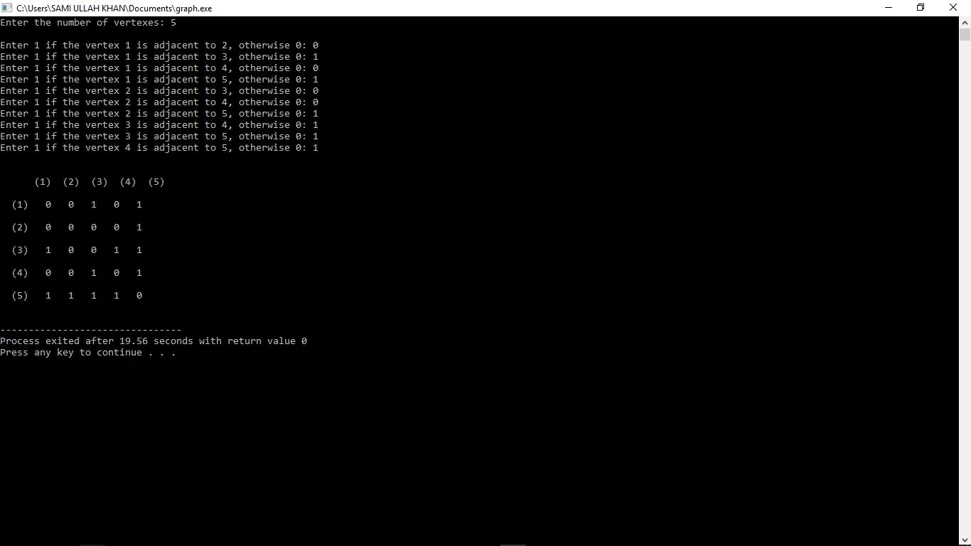

Figure 1: Time Independent Feature Set

// P r i n t 1 i f t h e c o r r e s p o n d i n g v e r t e x e s a r e c o n n e c t e d o t h e r w i s e 0 for ( i = 0 ; i < n ; i ++)

f
cout<<setw (3)<<" ( "<<i +1<<" ) " ;

for ( j = 0 ; j < n ; j ++)

f
cout<<setw (4)<<mat [ i ] [ j ] ;

g

cout<<"nnnn" ;

g

g

int main ( )

f
int i , j , v ;

cout<<" Enter t h e number o f v e r t e x e s : " ;

c i n >>v ;

int mat [ 2 0 ] [ 2 0 ] ;

cout<<"nn" ;
// Take input o f t h e a d j a c e n c y o f each p a i r o f v e r t e x e s .

for ( i = 0 ; i < v ; i ++)

2

f
for ( j | = i ; j | < v ; j ++)
f | i f ( i | != j )
 | f | cout<<" Enter |  |  |  | 1 |  | i f |  | t h e |  | v e r t e x |  | "<<i +1<<" |  | i s
 |  | c i n >>mat [ i ] [ j ] ;
 | g | mat [ j ] [ i ] | = | mat [ i ] [ j ] ;
 | e l s e
g |  | mat [ i ] [ j ] | = | 0 ;
g
PrintMat ( mat , | v ) ;

g

- Conclusion

in this lab we perform adjancy matrix that which vertix connected to which vertix and dispaly them in matrix form

3

